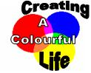
Ancient Art Practical Key Stage 3 Lesson Plan

Possible links to scheme of work unit: Introduction to the Rock Cycle
Particle model/ solutions/Change of state

National Curriculum link:

Range and content of Science key stage 3

3.4 The environment, Earth and universe
- geological activity is caused by chemical and physical processes

3.2 Chemical and material behaviour
- the particle model provides explanations for the different physical properties and behaviour of matter

Learning outcomes:

Rock cycle:
State that there are different sorts of rock with different characteristics and that pebbles and soils from different rocks consequently have different characteristics.
Explain how rocks are continuously been destroyed, transformed and reformed.

Particle model:
Discuss properties of solids, liquids and gases. Link these properties to science applications and how materials are chosen for a particular use.

Information:

- Cave paintings have been found throughout the world, from dark limestone caves in the South of France to rock shelters in Zimbabwe.
- Cavemen had limited knowledge about pigments, and few tools with which to make them. So they used the minerals around them to obtain colours.
- They would grind the minerals to a fine powder, and then use saliva, ear wax or animal fat to make the paint stick to the surface.
- They used chewed twigs as brushes.
- By the time of the Ancient Egyptian era, there were more colours available. These were made by heating natural materials.
- The Egyptians traded new brightly coloured minerals, such as Saffron. The Egyptians also developed better tools to grind them with.
- Egyptians found ways of extracting sap from plants, as well as using milk from cows to bind their pigments together to form paint.
- By Medieval times, people travelled and traded even more widely across Europe. A large variety of colours were now becoming available.

Suggested Lesson Plan:

Starter

Rock cycle:
- Have a powerpoint slide with a picture of Lapis Lazuli (mineral), Cochineal (insect producing red pigment carmine), Annatto (plant used to produce red food colouring), Indigo (plant once used to produce the blue for jeans), berries, charcoal (used for black colouring by cave men) and ask the students what they all have in common.

- Discuss how cavemen painted pictures on cave walls. Link this to present day and the fact that we haven’t “run out of rocks”. Discuss ideas of rock cycle.

Particle model:
Compare a large bit of chalk, chalk powder and chalk powder in water. Discuss state and change of state.

Main activity

Pupils to compare paints made from natural materials and modern day paints.

Then pupils make their own paint and use it to paint a picture or something else (they could paint a model volcano that they would have previously made - once the paint is dry they could erupt their volcano with vinegar and bicarbonate soda).

Worksheet with questions.

Plenary

Rock cycle:
Discuss what properties of the rocks would have required for cavemen to be able to make paint and link to selective use (texture/appearance/hardness/colour etc). This could be used to link to different kinds of rocks and their properties (following lessons).

Particle model:
Discuss properties of the pigment and binder. Discuss if you could separate the pigments and the binder again. Discuss what new properties the paint has that is useful. Compare and contrast the colours obtained naturally with the man-made pigments available today. Suggest reasons for making chemical pigments instead of using natural sources.

Resources Required:

For detailed information about sourcing the materials please see our resources sheet. http://www.creatingacolourfullife.co.uk/download/resourcelist.pdf

For this experiment it is only necessary to have an example of a natural pigment and one of a man-made pigment.

- Natural pigment (Ancient): Iron Oxides (yellow, red)
Malachite
Chalk Rock
Ultramarine Blue
Chalk Sticks
- Man-Made pigment (Modern): Powder Paints
- PVA Glue
- Eggs (Optional)
- Pestle & Mortar (if grinding is required)
- Plastic Cups
- Spoons
- Paint Brushes

Health and safety:

If using eggs as a binder, be sure there are no allergies towards them.
Care must be taken when grinding the ancient materials.

Further Work:

Pupils can make their own “cave chalk stick” using egg shells. Information about this is available on our website – www.creatingacolourfullife.co.uk under the experiments section. Relates to the concept that materials can be mixed together to form a new, usable item.

The ancient and modern paints that the children have made can be used to make a display, outlining what they have learned.

Answers worksheet:

- Minerals and rocks
- Spit, animal fat and/or ear wax.
- Browns, dark oranges, dark reds.
- Modern day paints are a lot brighter. Much wider selection of colours.
- Paint pigment: Dry, fine powder, not sticky, solid.
Binder: Very sticky, viscous, liquid.
- Sap from plants and milk from cows.
Ancient Art Practical

Introduction

Cave paintings have been found throughout the world. Cavemen had very few tools available to them, and they had to use the minerals and rocks around them to obtain colours. They would dig these minerals and rocks from the ground and then grind them into a fine powder.
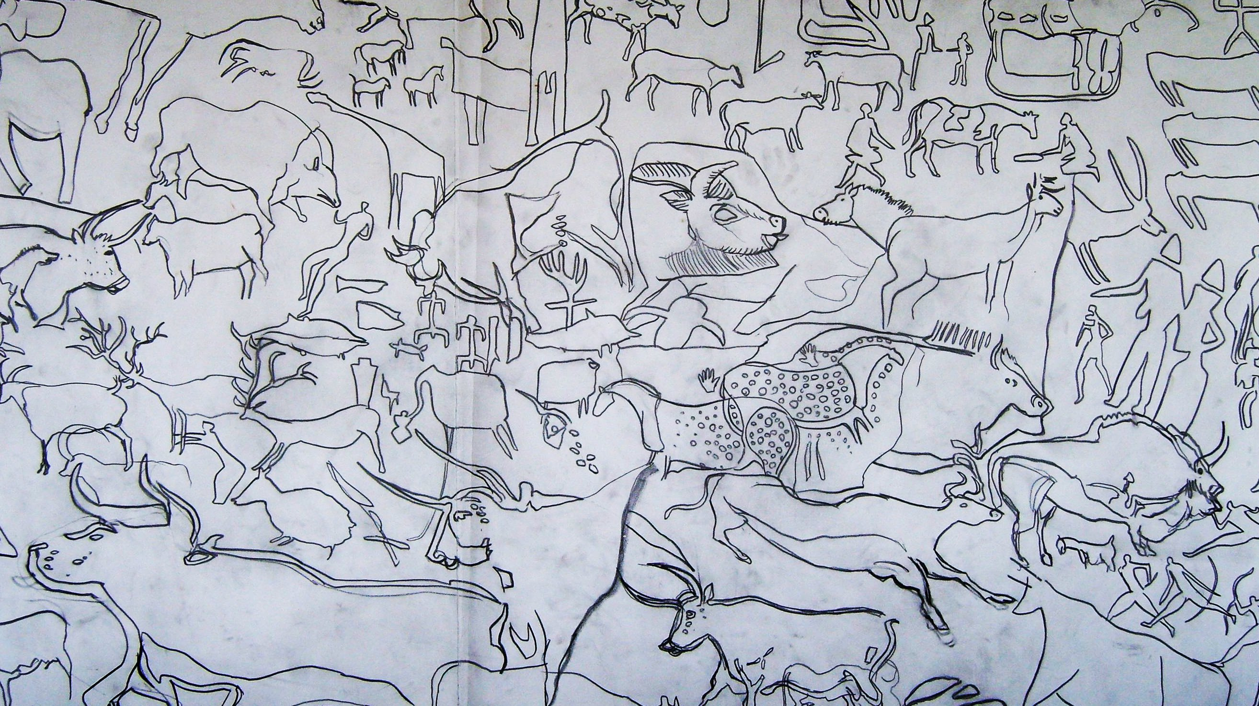

Modern cave art drawing.

The cavemen would use their spit, animal fat or ear wax to make their paints stick to the cave walls.

Cavemen would also use their fingers and the end of chewed twigs to paint their pictures with.

By the time of the Ancient Egyptian era there were more colours available. They found new brightly coloured minerals, and better tools to grind them with.

Egyptians found ways of extracting sap from plants, as well as using milk from cows to bind their pigments together to form paint.

By Medieval times people travelled and traded even more widely across Europe. A large variety of colours were now becoming available.

In this practical you will pretend that you are a caveman, and use natural materials in order to paint pictures, just like the cavemen did. You will also paint pictures using modern day paints and compare the colours.
Practical:

- Look at both the natural pigments and the man made pigments. What are the differences between them? Which is your favourite pigment?
- Add a teaspoon of your favourite pigment to a plastic cup. If you are using a natural material, make sure it has been ground to a fine powder first.
- Add a few drops of water and mix with a brush until you have a smooth paste.
- Separate the egg yolk from the egg white and dispose of the egg white. Add the egg yolk to your plastic cup. (If you are using PVA glue, add 2 teaspoons of it to the plastic cup instead).
- Mix the egg yolk with your pigment paste using a paint brush.
- You are ready to paint.

Questions:

- What did the cavemen use to make their paints?

……………………………………………………………………………………………………

……………………………………………………………………………………………………

- How did cavemen make their paints stick to the cave walls?

……………………………………………………………………………………………………

- Which colours did the cavemen have to paint with?

……………………………………………………………………………………………………

- What are the differences between the ancient cavemen paints and the modern day paints?

……………………………………………………………………………………………………

……………………………………………………………………………………………………

- What are the properties required to make a good binder?

……………………………………………………………………….…………………………...

……………………………………………………………………………………………………

- What did the Egyptians use to bind their pigments together to form paint?

……………………………………………………………………………………………………

……………………………………………………………………………………………………

